**21. Develop a C program to implement worst fit algorithm of memory management.**

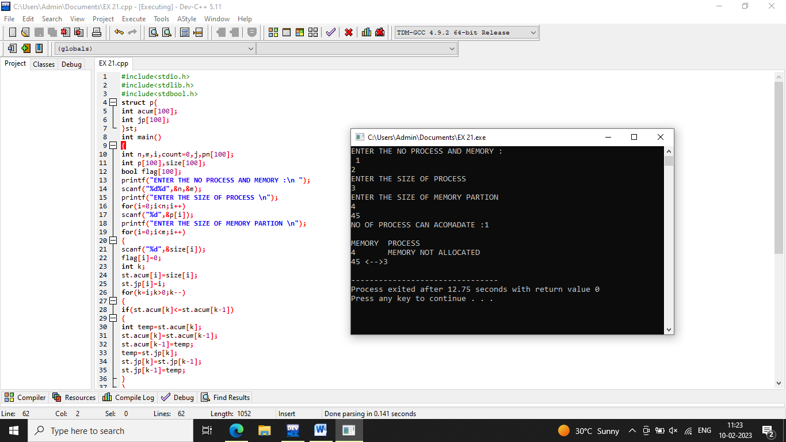

**22. Construct a C program to implement best fit algorithm of memory management.**

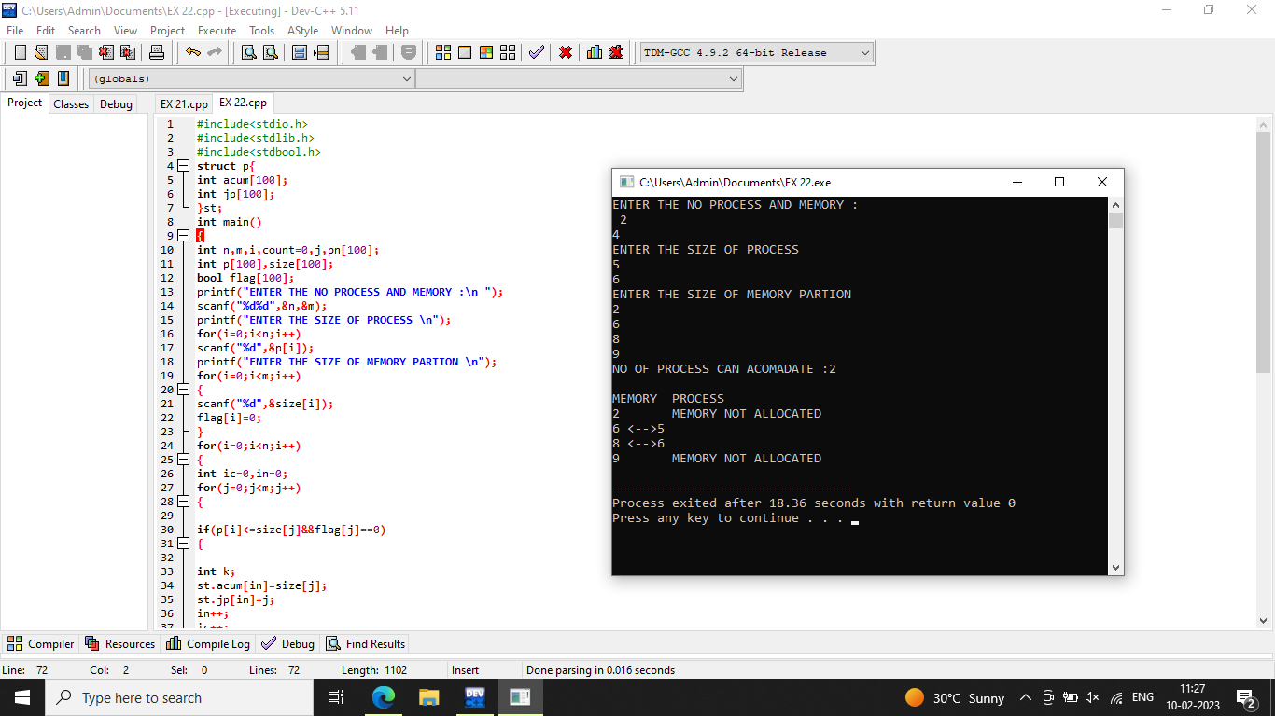

**23. Construct a C program to implement first fit algorithm of memory management.**

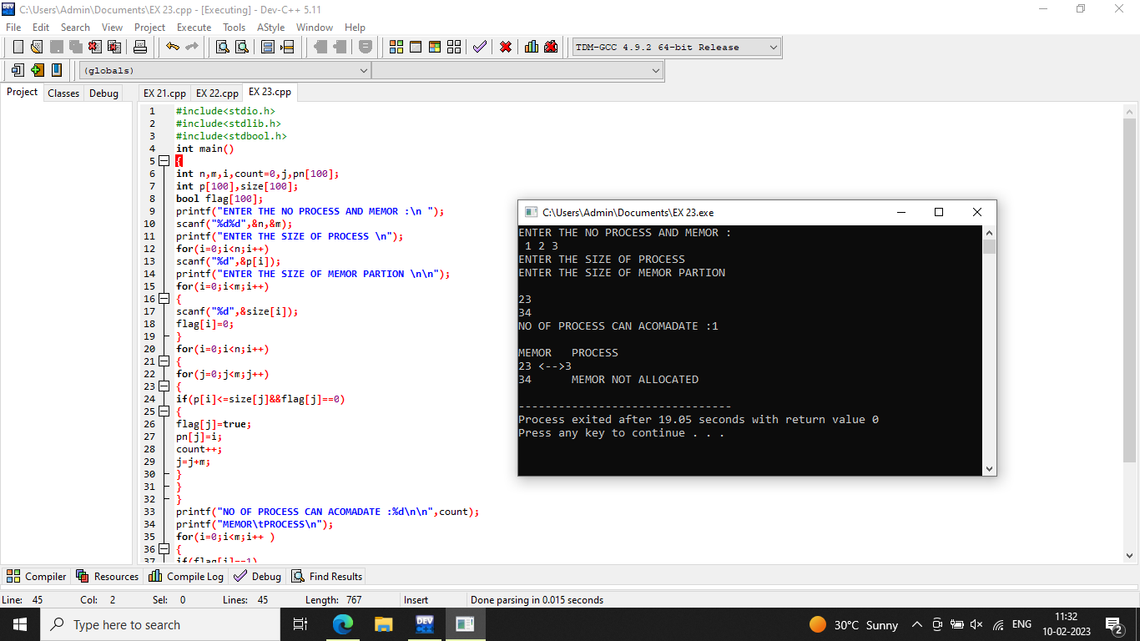

**24. Design a C program to demonstrate UNIX system calls for file management.**

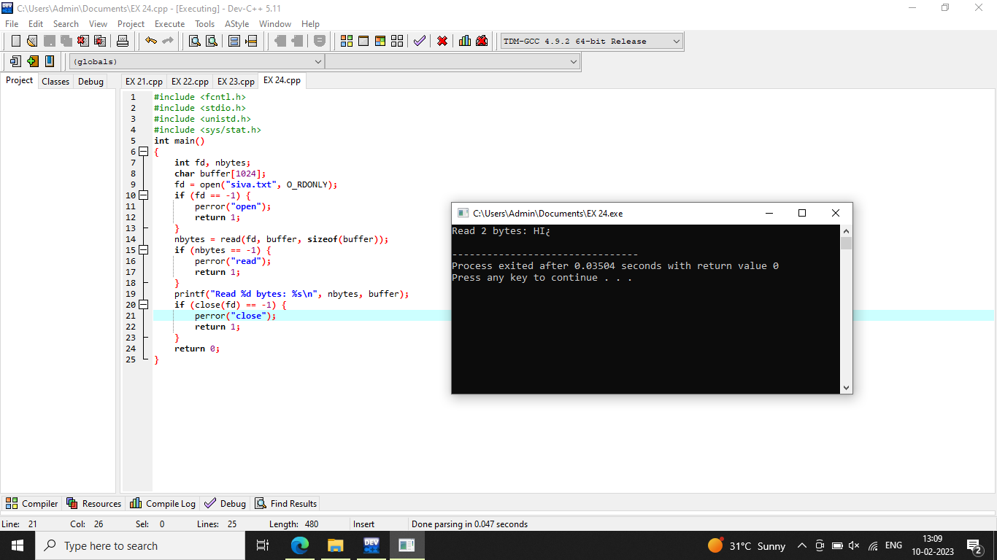

**25. Construct a C program to implement the I/O system calls of UNIX (fcntl, seek, stat, opendir, readdir).**

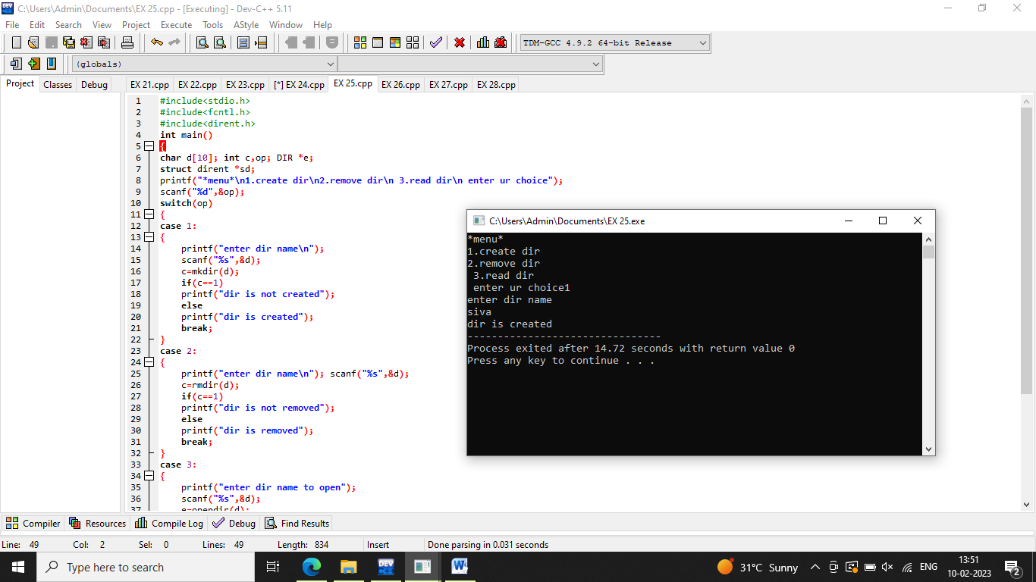

**26. Construct a C program to implement the file management operations.**

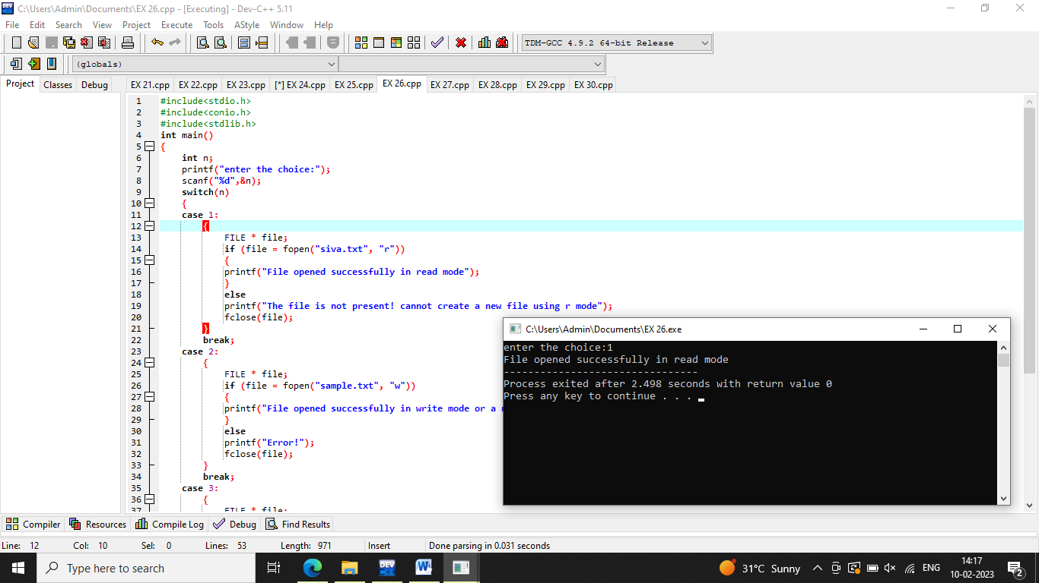

**27. Developa C program for simulatingthe function of ls UNIX Command.**

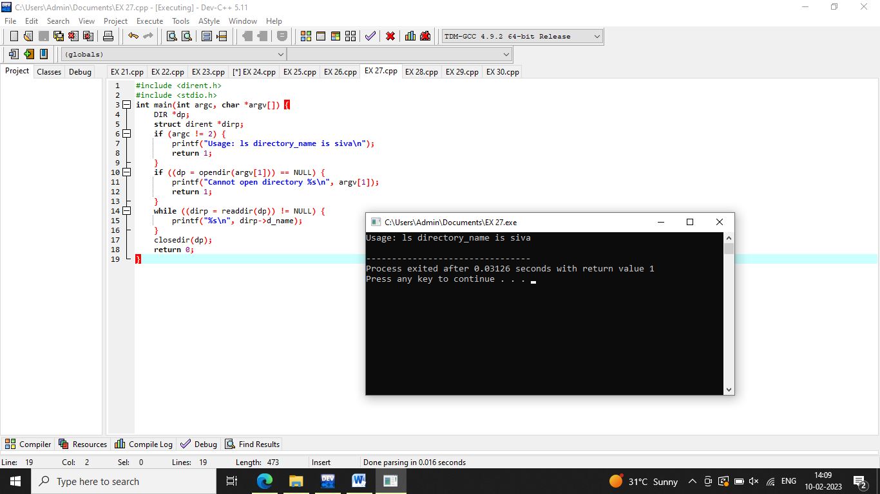

**28. Write a C program for simulation of GREPUNIX command.**

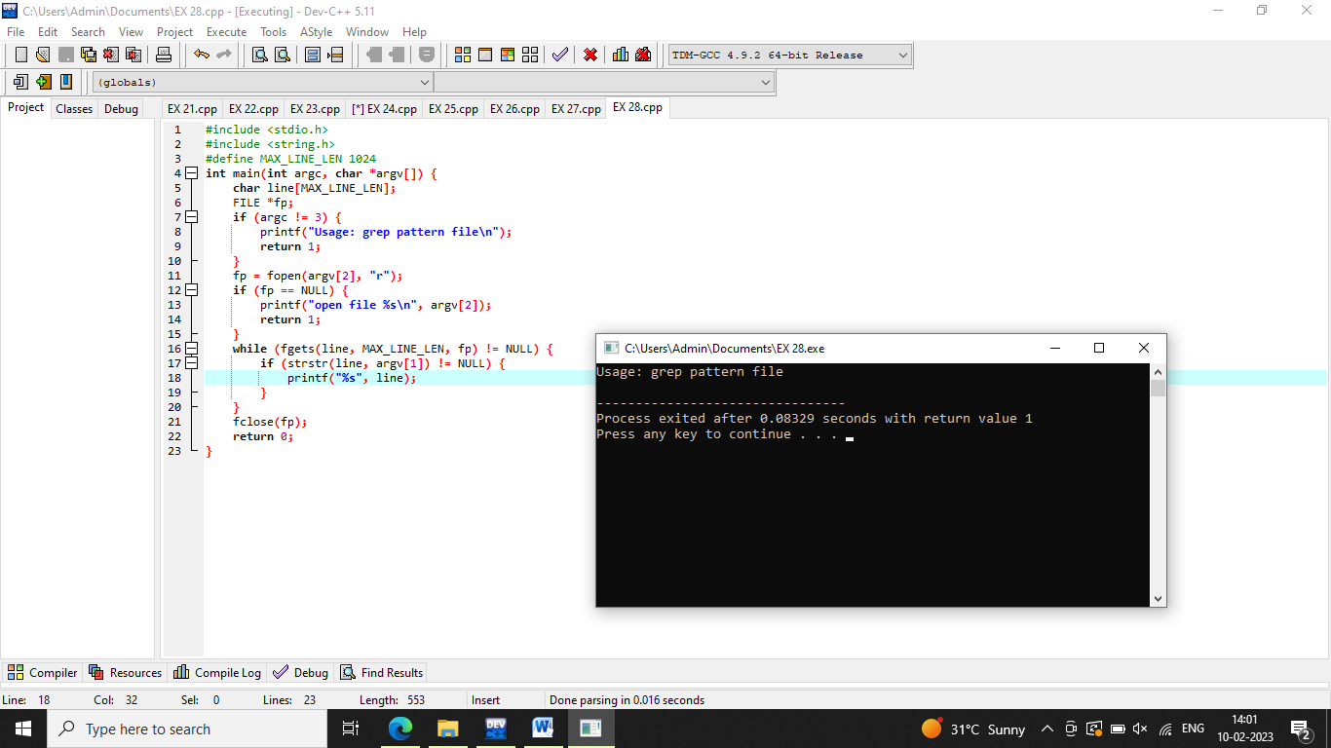

**29. Write a C program to simulate the solution of Classical Process Synchronization Problem.**

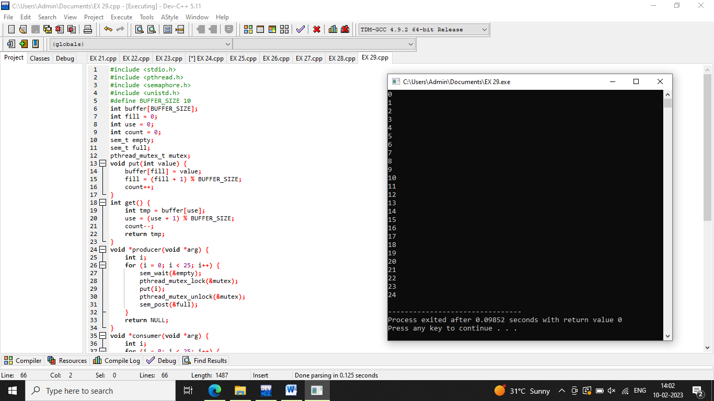

**30. Write C programs to demonstrate the following thread related concepts.**

**(i) create (ii) join (iii) equal (iv) exit**

